The Alchemists

9th March 2025

Bank of england project report

**Background**

As part of its function to regulate and supervise financial services firms through the Prudential Regulation Authority (PRA), the Bank of England (BoE) closely and continuously monitors the decisions and performance of over 1,500 financial services companies[1]. An integral part of this process is the analysis of text-based financial information such as those found around quarterly result announcements – a traditionally work-intensive affair. Using natural language process and large language models, this project aims to streamline this process, allowing the Bank of England to more efficiently and accurately assess risk levels of global systemically important banks (G-SIBs).

Earnings calls are typically one of the most analysed text-based financial resource[2] and since the Q&A section specifically has less (although not zero) oversight from the banks themselves, these parts of the transcripts have been selected for analysis. This project endeavours to create a product that BoE analysts can use to extract key trends, talking points and create financial predictions based on the data contained in these Q&A sessions without having to comb through transcripts manually.

**Data Selection and Processing**

A selection of the largest banks in European and US market were chosen[3] to maintain BoE-specificity. A javascript scraper was used to extract text and metadata from financial services research platform Seeking Alpha, which upon compiling resulted in a workable table of raw data. An initial round data cleaning included ensuring consistency with person names, and the correct labelling of roles.

This table was then joined with information containing which company each analyst present on the Q&A calls belonged to, to allow for an extra avenue for analysis.

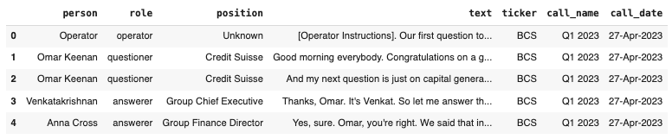

Figure : Raw table of Earnings Calls Q&A data from Seeking Alpha

To add a method of evaluating performance of NLP tools later in the project, stock price data was inputted using an API from Alpha Vantage. Three performance metrics were defined: call_day_price_change, earnings_period_price_change, and quarter_price_change, referring to the change in share price on the day of the call, in a ten-day window, and in a quarter-length window.

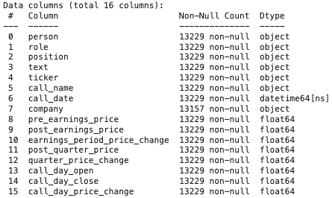

Figure : Table structure after inputting company information and stock price data

To preprocess data in the text columns, stopwords were removed from the text columns using the Natural Language ToolKit (NLTK), as well as manually, along with lemmatisation, and other standard preprocessing techniques in data science.

**Initial Data Exploration & BERTopic**

To further understanding of the data, wordclouds and bar charts for the most popular words were created. Instantly these provide insight into key inter-bank differences in topics discussed, for example Credit Suisse calls mentioned the APAC market more prevalently than others, as seen in Figure 3.

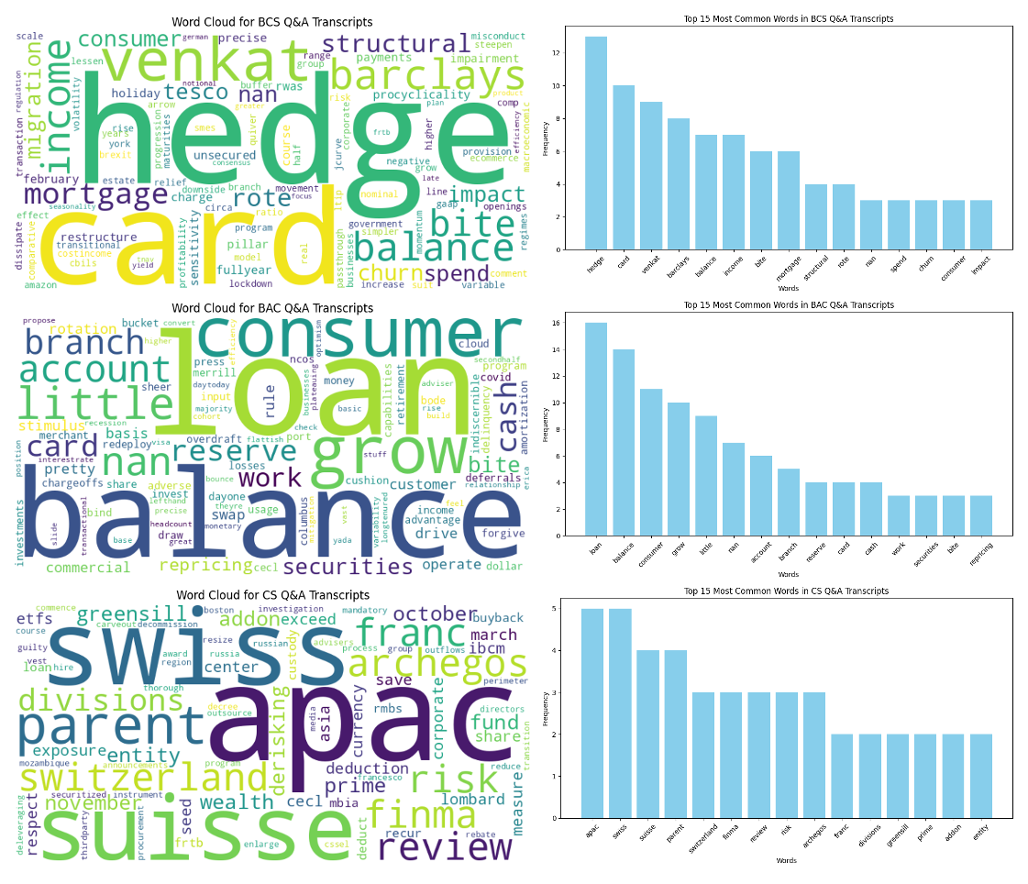

Figure : Wordclouds and most common words for Barclays, Bank of America, and Credit Suisse

BERTopic in conjunction with HSBSCAN was applied on the full corpus for topic discovery. The results which showed distinct topics pertaining to Hong Kong markets and hedge strategies were of note and confirmed that topic analysis should be part of the final product.

**FinBERT for Sentiment Analysis**

FinBERT was used to assign each comment as having a positive, neutral or negative sentiment, alongside a sentiment score, these were then averaged out for each call to provide an average sentiment score.

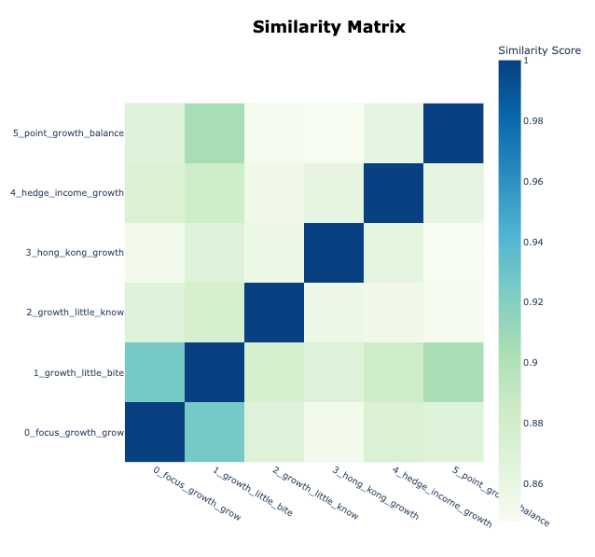

Figure : BERTopic detected six distinct topics covered in the corpus

FinBERT showed that the calls heavily skewed towards the neutral classification. Whilst inherently not a bad thing, having an overrepresented neutral bin is of limited use to analysts at the Bank of England and so to counter this, the FinBERT model was tuned using the sbhatti/financial-sentiment-analysis dataset containing financial sentences from two sub-datasets (FiQA, Financial PhraseBank) with sentiment labels. As well as improving the model, tuning had the desired effect of increasing the percentage of texts falling into positive or negative classification.

Plotting the percentage of negative and positive comments against stock price changes resulted in Credit Suisse being the clear outlier (Figure 6). Since Credit Suisse is indeed an outlier in the banks included for analysis in the sense it went through financial distress leading to failure, this suggests that there is merit in using NLP for analysis on textual documents. Most banks do not have a clear correlation between sentiment and change in stock price, implying that the financial health of banks is generally resilient to sentiment shown on earnings calls Q&As segments. However, in Credit Suisse’s lone case, the apparent link between share price change and call sentiment suggests that these two values may be linked in the case of a bank performing poorly. This hypothesis should be explored further with more case studies of failing banks.

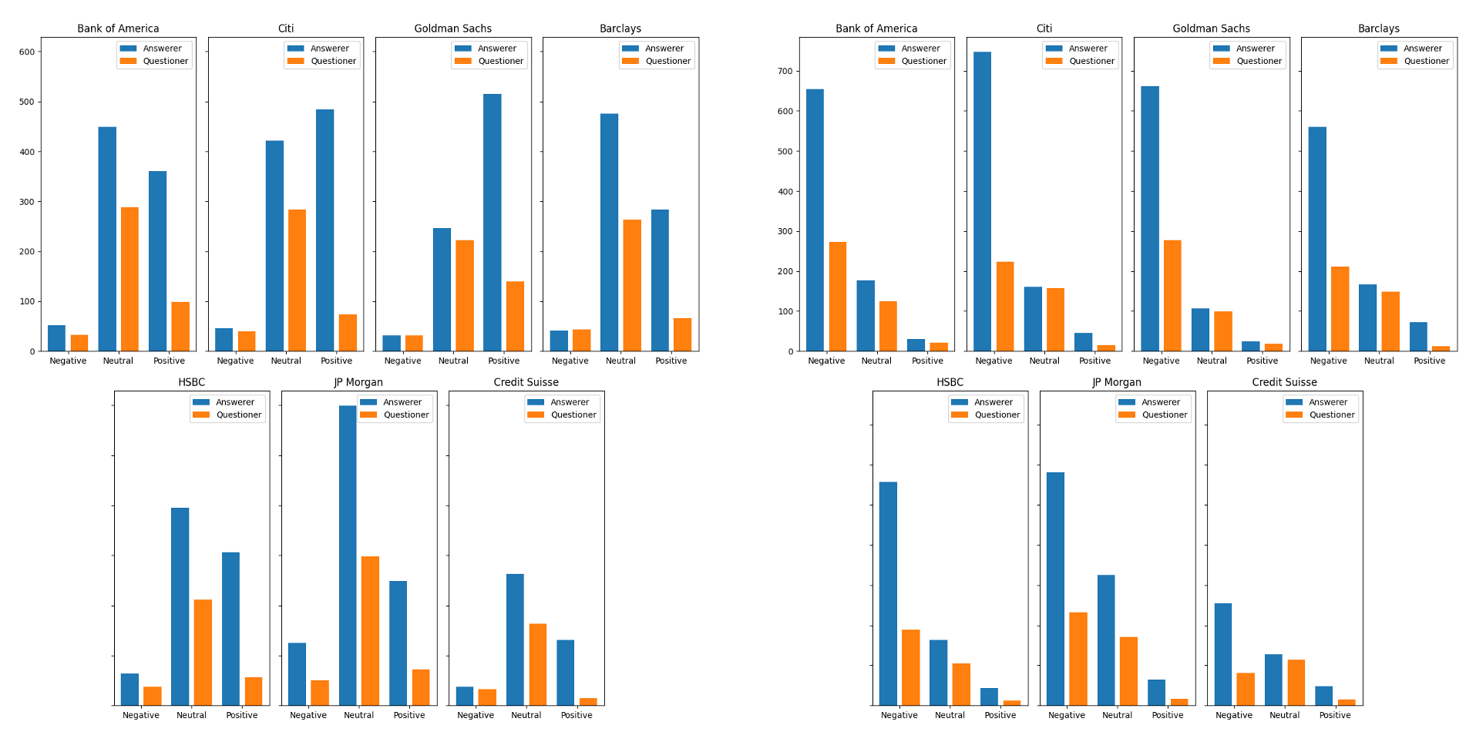

Figure :Untuned (a) and tuned (b) FinBERT sentiment classification for all comments in Q&A Earnings Calls

(a)

(b)

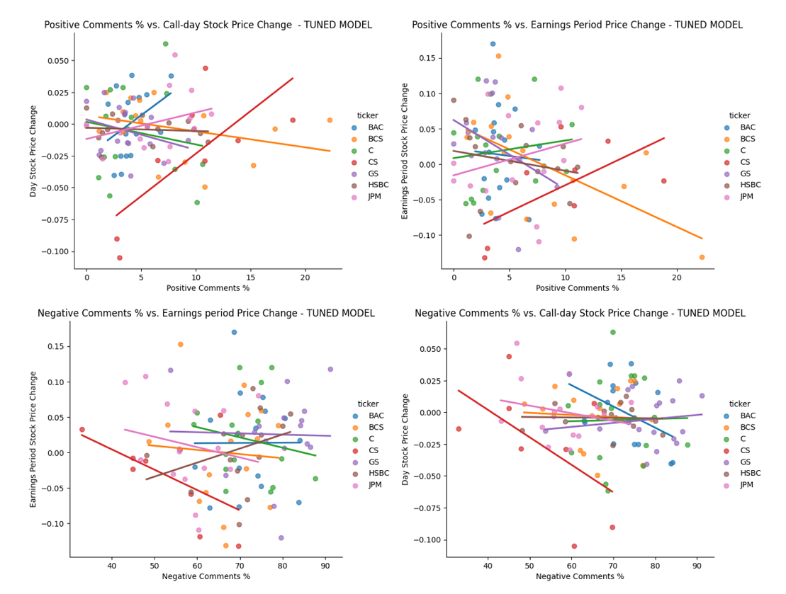

Figure : Stock price change against percentage of positive and negative comments (as evaluated by the tuned FinBERT model) present in the Q&A transcript depicting, the now failed, Credit Suisse as the clear outlier

The positivity, $P$, of a string of comment was introduced as a new metric, defined:

$$P= \left\{\begin{aligned}S_{p}-S_{n}+1, if the sentiment is "positive" \\ S_{n}-S_{p}+1, if the sentiment is "negative" \\ 0.5, if the sentiment is "neutral"\end{aligned}\right.$$

Where $S_{p}$ is the positive confidence score and $S_{n}$ is the negative sentiment score.

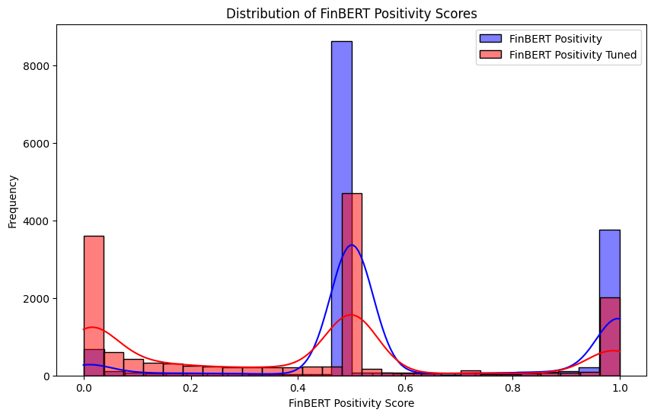

Figure : Distribution of positivity scores

This allowed for the creation of graphs present in Figure 8 which plot stock price change on the same time axis as average positivity, and Figure 9 which shows that the reactivity of stock price for failing banks (such as Credit Suisse and Silicon Valley Bank* with respect to sentiment is in contrast to the lower volatility over longer periods as the market comes to the realisation that the bank is failing.

When analysing individual calls, having knowledge of the positivity of that call in relation to the average positivity of calls for that bank generally, and in relation to the average positivity of calls that quarter were deemed important, to give the BoE analyst most context around displayed result in the final product.

* data from SVB was included later in analysis to discern whether our models were adept at identifying banks in distress, as this would be useful for BoE

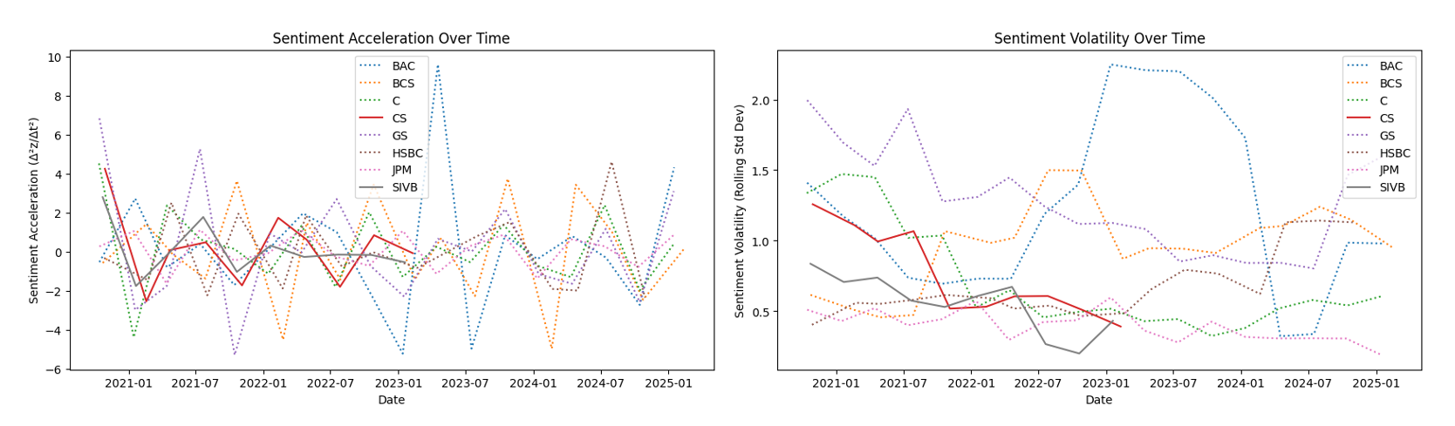

Figure 9: Sentiment acceleration and volatility over time, with Credit Suisse and Silicon Valley Bank highlighted

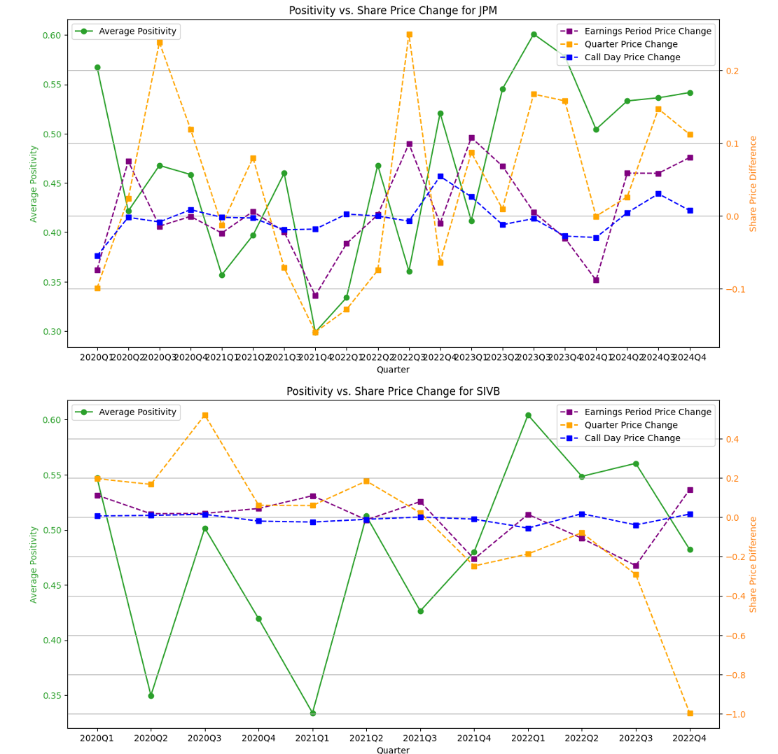

Figure : Positivity over time overlaid on stock price change around earnings calls

**LLMs for Call Summary and Key Points**

The Perplexity API, built off Perplexity AI’s Sonar LLM, was used to create a user-facing summarisation model based off the data contained in the scraped earnings calls data.

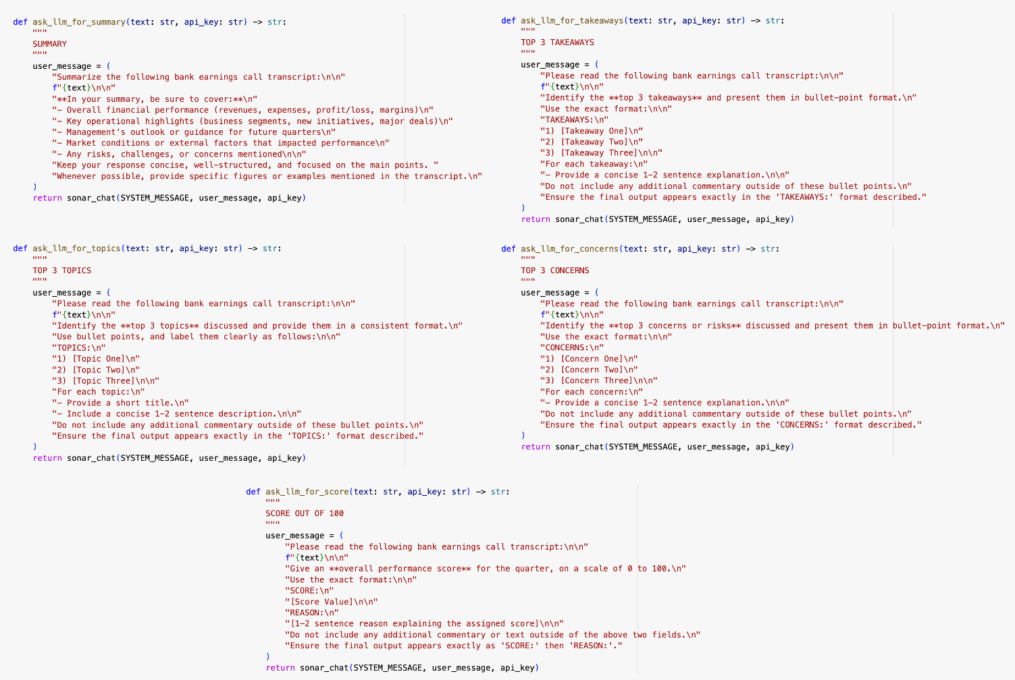

Figure 10: Code snippet containing five defined LLM functions as read by the Perplexity API on earnings call data

The five functions, as defined in figure 10, aim to

1. Summarise the full Q&A transcript
2. Outline three heavily discussed topics
3. Provide the BoE analyst with three takeaways for actioning or further analysis
4. Notify the BoE analyst of three potential causes of concern
5. Score the bank’s performance in that financial quarter

This code’s output was to serve as the body of the BoE-facing product. Clear, concise and accurate results, alongside a consistent format were the priorities.

**XGBoost to Predict Price Change**

With a view to provide the BoE with a prediction on a bank’s financials in the aftermath of an earnings call, a neural network using eXtreme Gradient BOOSTing (XGBoost) was created, with text contained in the Q&A transcript vectorised using Term Frequency-Inverse Document Frequency (TF-IDF) acting as the sole input variable.

Creating an effective model necessitated introducing data from more calls and more banks, so a further seven banks (139 calls) were added to the dataset. The ideal output for this model was to inform an analyst how in which direction and how much stock price would change after an earnings call, based on a corpus of trained data from previous calls, however models using this approach were ineffective prompting a switch from an XGBoost for regression to an XGBoost for classification.

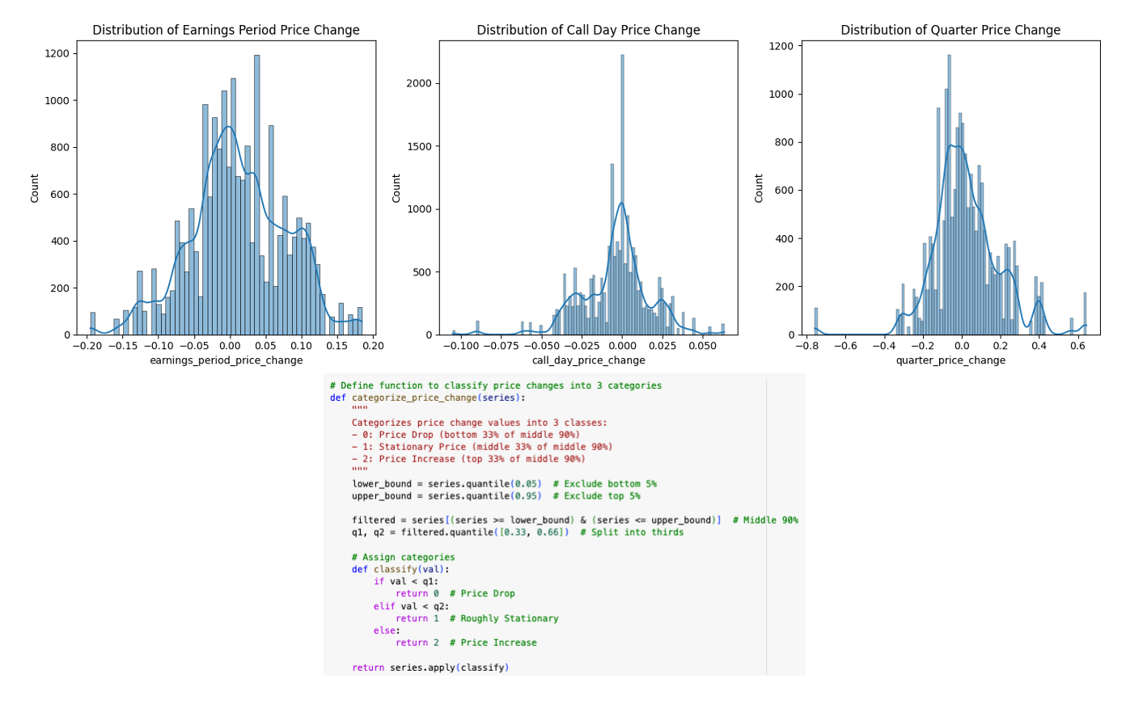

Figure 11: Differences in distribution of stock price changes dependant on time window used

Since three metrics are stored for stock price change, categories had to be adjusted for the distribution of each. Thus three categories were defined: price drop, stationary price, and price increase relating to the bottom 33% (most negative), middle 33% (most roughly stationary), and top 33% (mostly positive), when excluding 5% extremes on either end.

XGBoost models for all three target metrics were trained, with techniques including class weighting, Synthetic Minority Over-sample Technique (SMOTE), and hyperparameter tuning utilised to optimise results.

The quarter-period stock price change model produced by XGBoost resulted in a 58.3% accuracy – a **75.1% increase** from a 33% random selection (of price drop, price stationary, or price increase). This is an output to include in the client-facing product.

**Results and Interface**

With data processed, insights collected, and research completed, the decision to create a streamlit app was taken due to its speed, ease and extensive documentation.

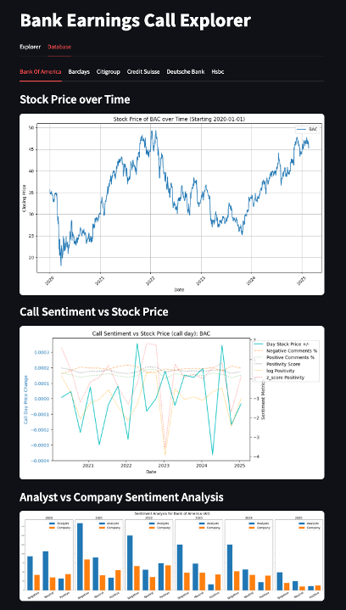

Figure 12: Section 1 - General bank information

When exploring a bank contained in the database, general information pertaining to stock price movements, average call sentiment against stock price, and sentiment analysis for analysts vs internal employees are visible to the user. Upon selecting a call to explore, a stock price prediction is given by the XGBoost model outlining whether the price is predicting to increase, stay stationary or decrease. This is shown alongside a positivity value with context around the bank and that financial quarter.

Figure 13: Section 2 – call-specific price change predictor and positivity value

The third section of the interface contains the output from the Sonar-LLM with call summary, topic analysis, takeaways, concerns and a financial score.

Figure 14: Section 3 – LLM output

The user is also given the option to upload a transcript, allowing for analyses into banks and calls outside of the existing corpus.

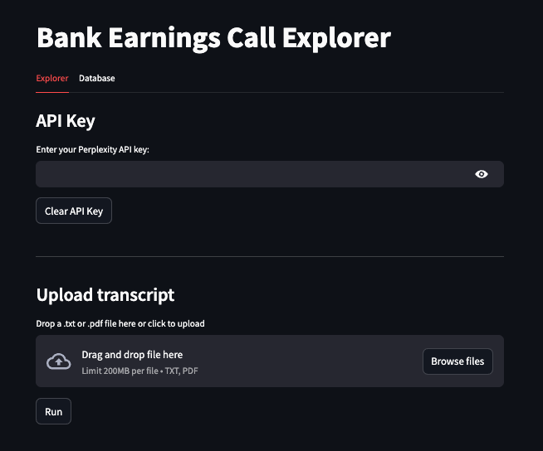

Figure 15: Section 4 – Option to upload transcript

**Conclusion**

The output is successful in informing the user of call-specific sentiment, relating it to contextual values for the financial quarter, and chosen bank. The user is informed of a general summary, topics covered, potential concerns, and an indication into whether the stock price of the bank is likely to go up or down.

More data and research are required to truly attest to the usefulness of the product, but accurate and consistent LLM outputs and an XGBoost model operating at 75% better than random, supplemented by graphics and statistics to help the user understand the data has resulted in a satisfactory prototype for a potential model for deployment.

Observing clear outliers and negative price change predictions and sentiment for failed banks like Silicon Valley Bank and Credit Suisse highlight the potential for this solution’s prowess in identifying financial distress, allowing BoE employees to act before crisis strikes.

Opportunities for further improvement and research include:

* Assessing accuracy in sentiment of key individual analysts and/or banks and risk management organisations, when compared to financial changes to see whether there are specific participants in Q&As are markers to track
* Adding more data around Q&A transcripts, such as financial earnings statistics, general market data, to enhance the XGBoost model and contextualise the LLM output
* Expand the XGBoost model to look at price changes for the earning period and call date specifically, tuning it to provide better results
  + Increase the number of categories so BoE can distinguish between predicting a drop in stock price within a normal range, and predicting a bank in danger of failing
* Liaising with BoE to assess which graphics and metrics are most of use and iterate accordingly.

1. <https://www.gov.uk/government/publications/recommendations-for-the-prudential-regulation-committee-november-2024#:~:text=The%20Prudential%20Regulation%20Committee%20(PRC)%20is%20responsible%20for%20the%20exercise,insurers%20and%20major%20investment%20firms>.
2. <https://corporatefinanceinstitute.com/resources/valuation/earnings-call/#:~:text=3.,their%20answers%20for%20certain%20questions>.
3. <https://www.fsb.org/2024/11/2024-list-of-global-systemically-important-banks-g-sibs/>